**1. Observed Level Data**

Oxygen profile data are for the whole time period (since 1900)

Profiles have been quality controlled as in IAP paper

Oxygen anomalies (relative to Viktors climatology) have been quality controlled and oxygen values linked to large anomalies rejected

Only profiles with at least 3 levels retained

The total number of profiles on observed levels is **665537**

Observed Level quality-controlled profiles are in the file **OXLIJING_OBS.dat**

**2. Corrections relative to USA data**

**Depth-averaged yearly corrections** (e.g. differences relative to USA ***collocated*** profiles) have been calculated for 21 countries (96% of all oxygen data).

Corrections are retained only for years where at least 50 country-collocated pairs are available.

No correction is applied for years/countries where number of collocation pairs is zero or is insufficient.

The time-series of corrections are shown in Fig.1.

Corrected observed level quality-controlled profiles are in the file **OXLIJING_OBS_corrected_depth_average.dat**

3. Profiles interpolated at 10-m levels

Observed level quality-controlled profiles have been interpolated on 10-m levels using parabolic interpolation. In case of unrealistic feautures due to non-linear interpolation (e.g. “overshooting”) linear interpolation has been used.

10-m level interpolated profiles are in the file

**OXLIJING_10m_corrected_depth_average.dat**

**There is a total of 606157 interpolated profiles**

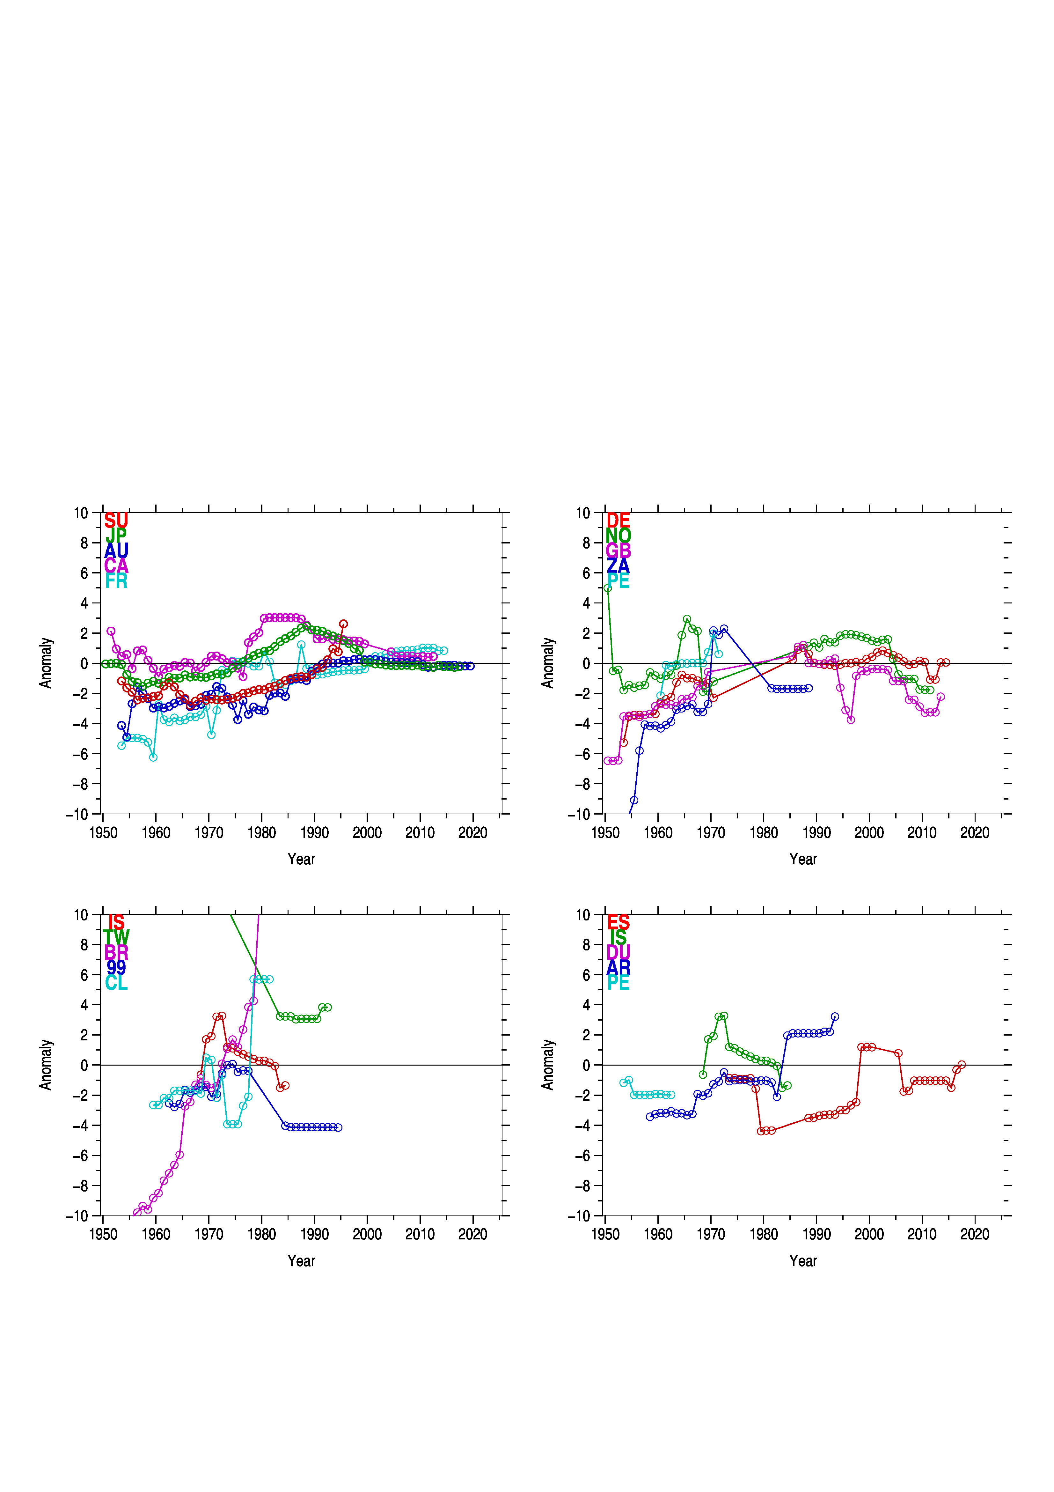**Fig. 1 Time series of oxygen corrections for main data contributing countries. Aorrections are available only for years marked by circles.**

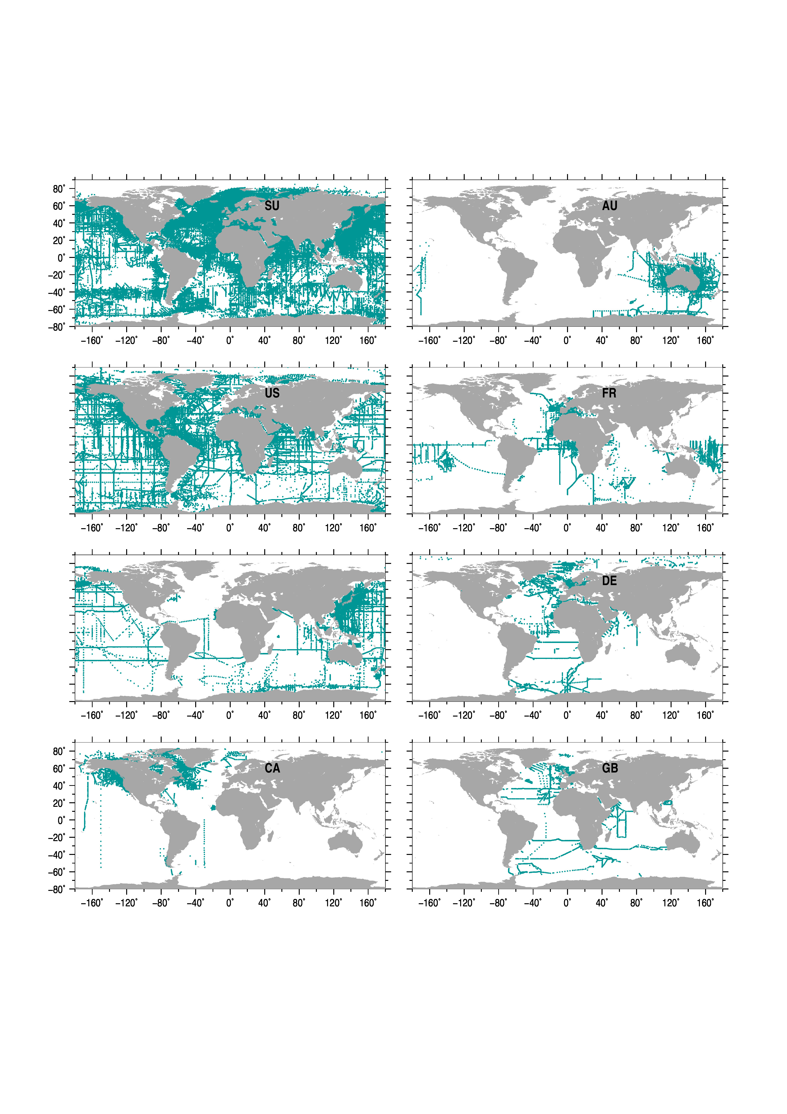**Interpolated profiles**