**1. Observed Level Data**

Oxygen profile data are for the whole time period (since 1900)

Profiles have been quality controlled as in IAP paper

Oxygen anomalies (relative to Viktors climatology) have been quality controlled and oxygen values linked to large anomalies rejected

Only profiles with at least 3 retained oxygen levels

Argo profiles are adjusted as in Gouretski et al. 2024

OSD: 543,77 profiles

CTD: 30,354 profiles

ARGO: 214,303 profiles

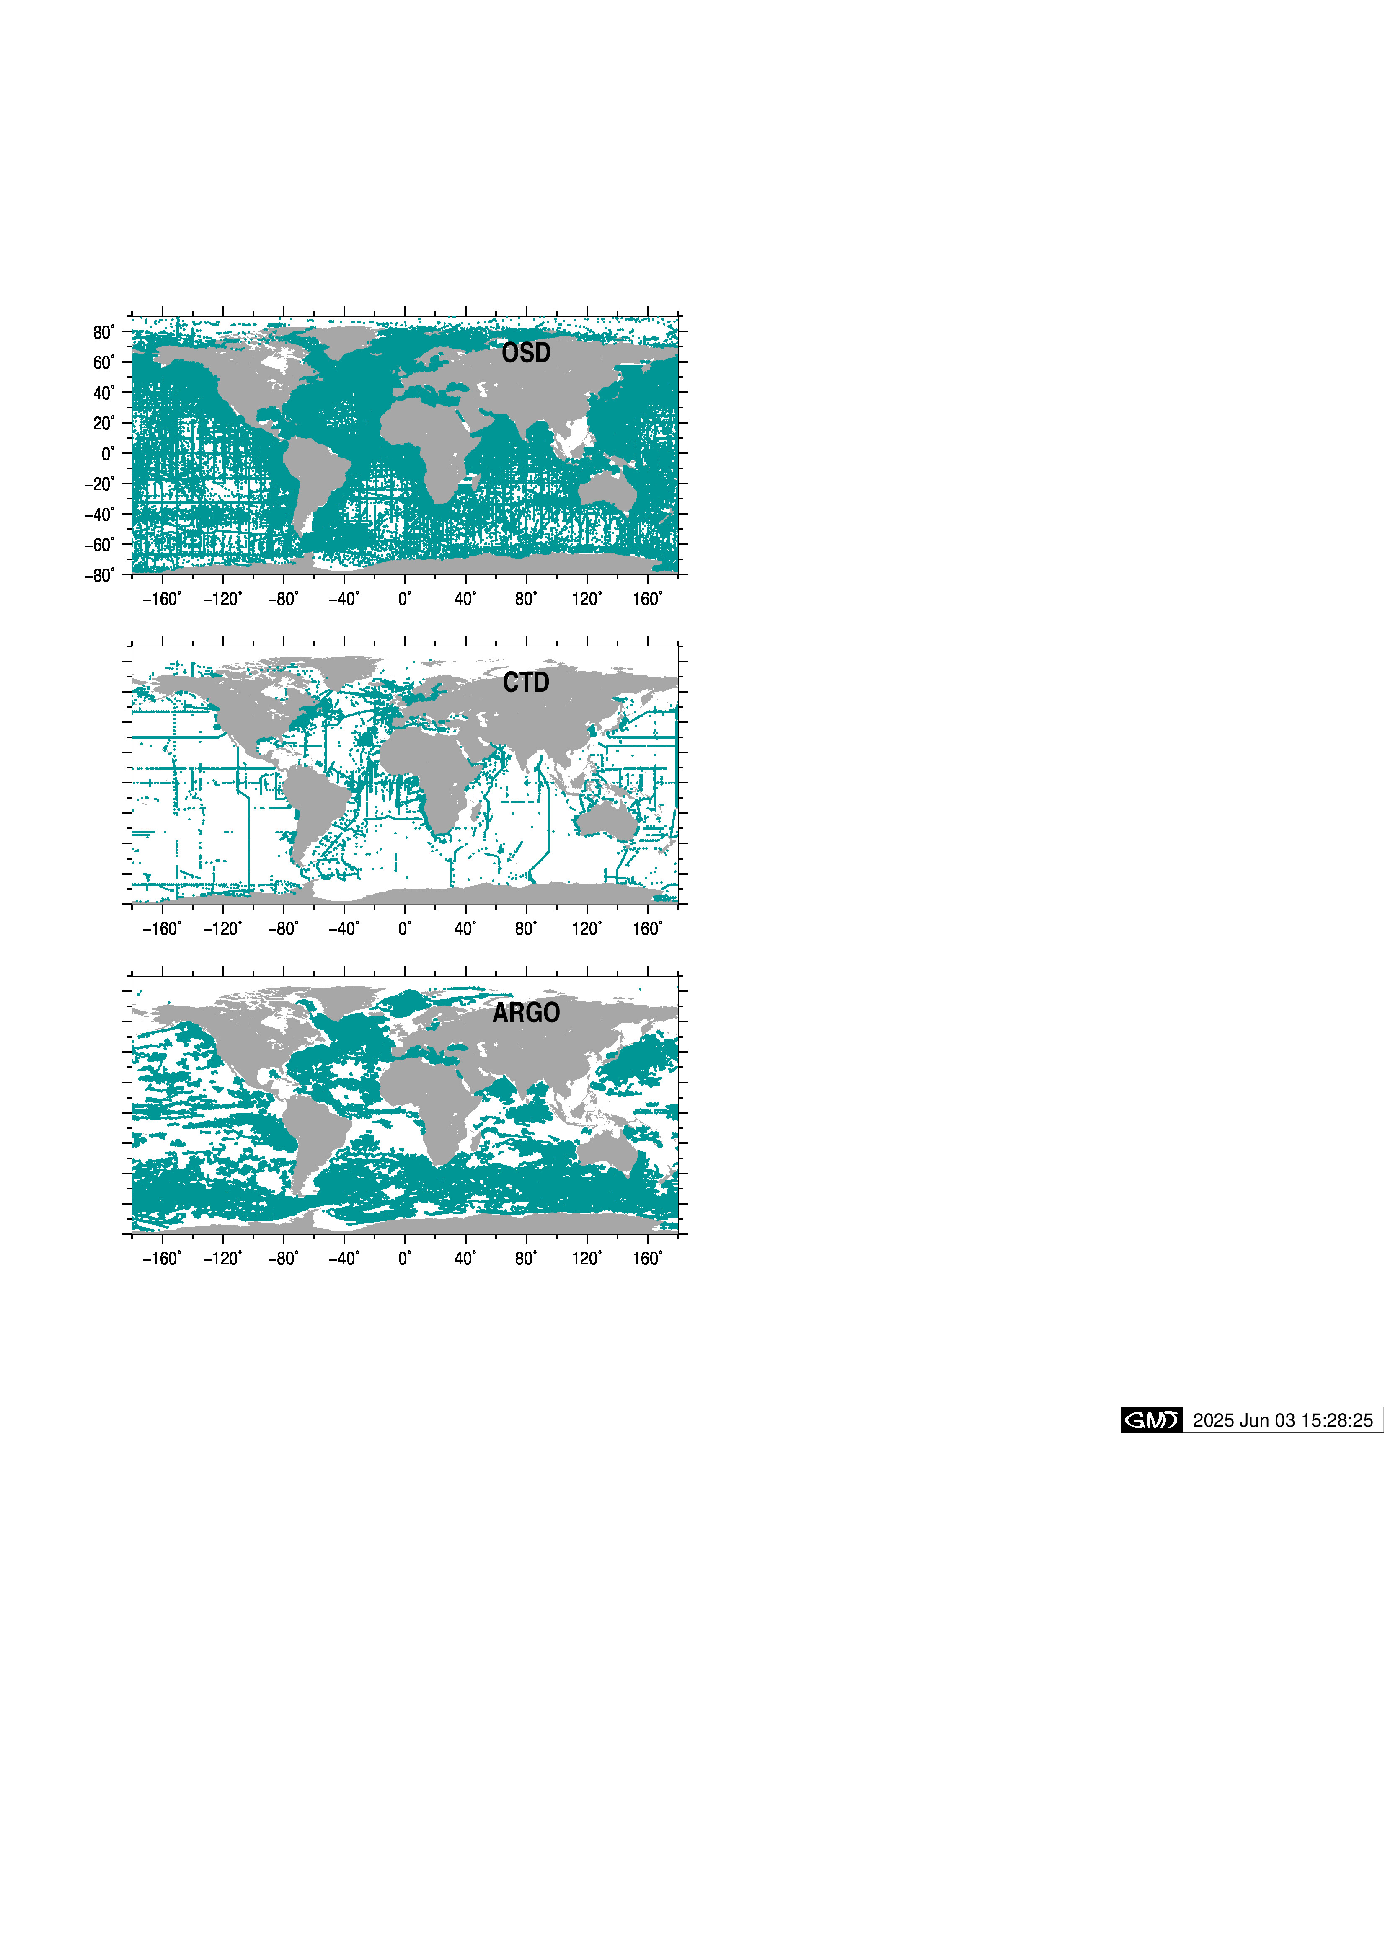

**Fig. 1 Profile locations**

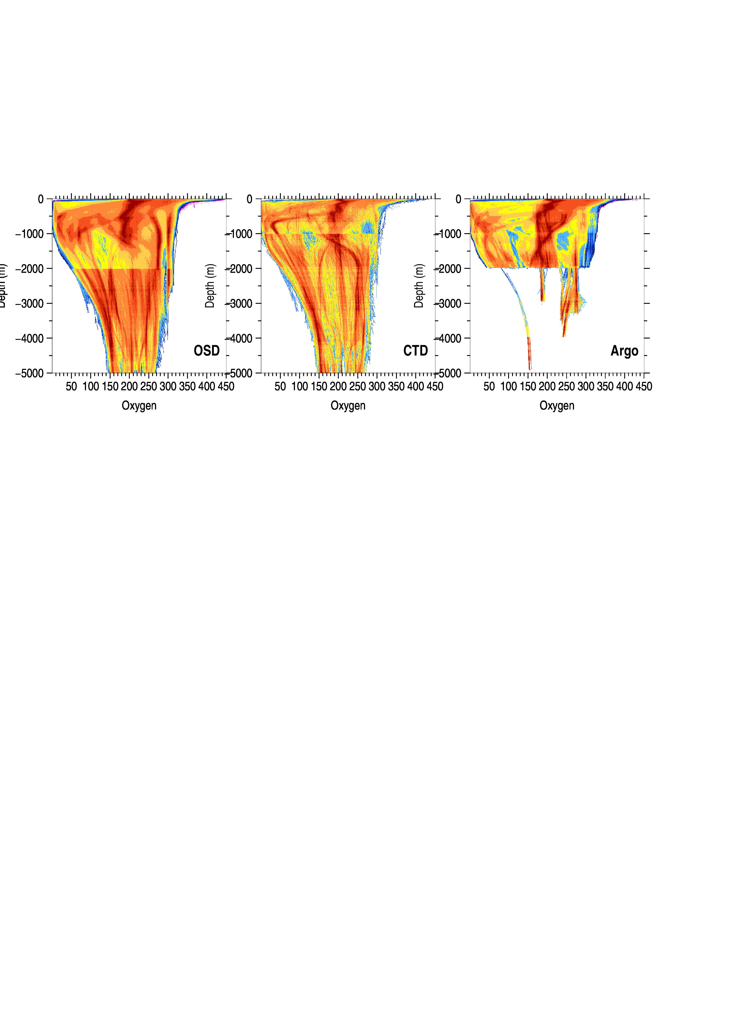**Fig.2 Normalized histograms (for the overall check of 10-m interpolated profiles)**