**IAP/CAS (Institute of Atmospheric Physics, Chinese Academy of Sciences) Ocean Dissolved Oxygen Profile Dataset**

**Format Description (DAT files)**

IAP/CAS (Institute of Atmospheric Physics, Chinese Academy of Sciences) provides quality-controlled and bias-corrected ocean dissolved oxygen profile data. This dataset includes in situ ocean oxygen profile data from 3 major instruments: OSD, CTD, and Argo. OSD instrumentation is represented by bottle casts with oxygen determined by the Winkler method. CTD profiles are obtained mainly through the electrochemical sensors, whereas Argo float profiles contain data mainly obtained by optodes. The total number of profiles from all three platforms exceeds 1.2 million from 1920 to 2022.

The quality-controlled (QC) was implemented by IAP-QC including 9 different QC checks to identify different kinds of erroneous data and/or outliers. We used Gourteski et al., (2024) oxygen correction scheme to correct the remaining systematic bias in the Argo data. Applying the new QC procedure and bias adjustment resulted in a new global ocean oxygen dataset from 1920 to 2023 with consistent data quality across bottle samples, CTD casts, and Argo floats.

This README provides the variable information for the DAT format files (from January 1940 to August 2023) for dissolved oxygen *in-situ* observations (vertically interpolated to standard levels).

**OSD/CTD data are stored in the file named “OXY_10m_OSD_CTD.dat”.**

**Argo data are stored in the file named “OXY_10m_ADJ-DAC_QC-DAC_BIASCORR-IAP_AQC-IAP.dat”.**

**Here, we describe the data format with an example (the first profile in “OXY_10m_ADJ-DAC_QC-DAC_BIASCORR-IAP_AQC-IAP.dat”)**

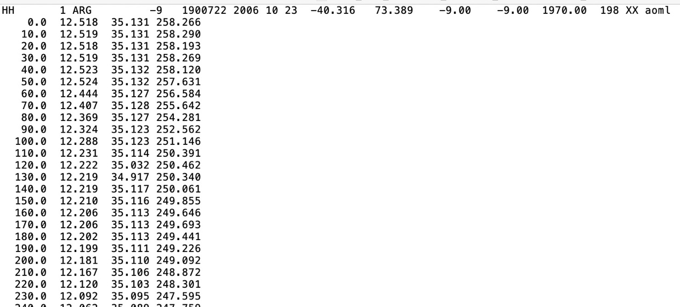

**The first line is the profile information, contains 16 info, described below:**

1. HH: indicator for header line
2. 1: profile number
3. ARG: instrument type (ARG is Argo; there are two other instrument types: OSD and CTD)
4. -9: Cruise Number
5. 1900722: WOD profile ID
6. 2006: year
7. 10: month
8. 23: day
9. -40.316: Latitude
10. 73.389: Longitude
11. -9.00: observed bottom depth
12. -9.0: GEBCO bottom depth
13. 1970.00: deepest observed level depth
14. 198: number of observed levels
15. XX: country code
16. AOML: ship/platform name

**The following lines are the profile data, 4 rows:**

Row-1: depth (m)

Row-2: temperature (oC)

Row-3: salinity (psu)

Row-4: oxygen (µmol kg-1)

**DATA CITATIONS:**

[1] Viktor Gourteski, Lijing Cheng, Juan Du, Xiaogang Xing, Fei Chai, Zhetao Tan. 2024. A consistent ocean oxygen profile dataset with new quality control and bias assessment. *Earth System Science Data Discussions*, 2024, 2024: 1-27.

Contact:

Viktor Gouretski and Lijing Cheng

IAP/CAS

Viktor Gouretski ([viktor.gouretski@posteo.de](mailto:viktor.gouretski@posteo.de)); [chenglij@mail.iap.ac.cn](mailto:chenglij@mail.iap.ac.cn)

**11/07/2024**